Make Your Pumpkin Last!

- Disinfect It!
Wipe your pumpkin with a solution of 1 c. bleach to 2 qt. water to eliminate bacteria that causes decay.

- Oil It!
Rub any cut surfaces with vegetable oil to keep moisture in.

- Scent It!
Sprinkle cinnamon – a natural antiseptic – inside your pumpkin to prevent mold.

- Spice It!
Shake in some hot pepper to keep critters from feasting on your décor.

- Shade It!
Shield your pumpkin from direct sun to delay decay.
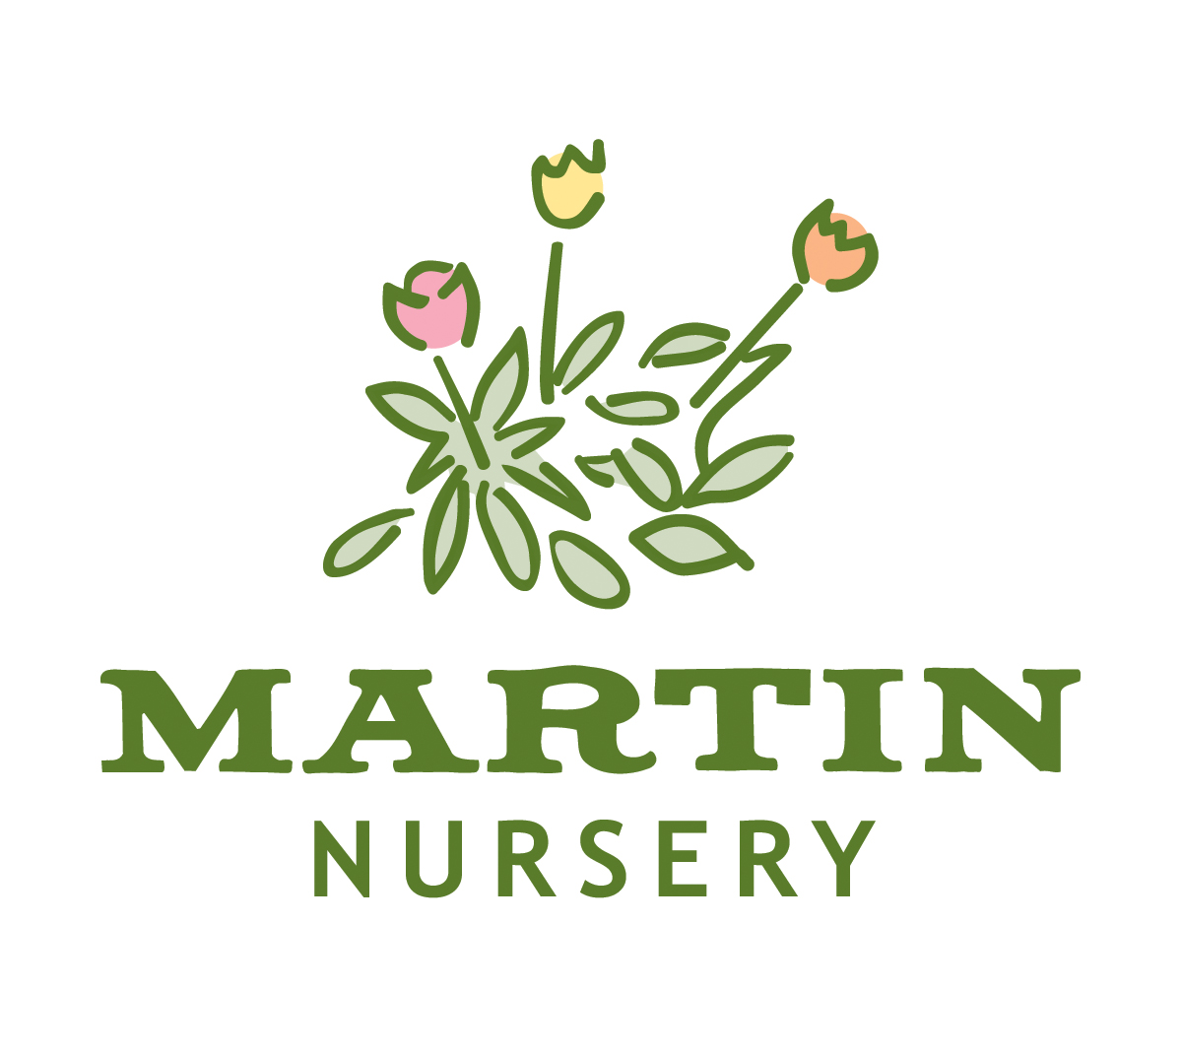
198 Martin Nursery Road, Greenville, SC 29607
(864) 277-1818
www.martinnursery.com
www.facebook.com/MartinNursery

